Just Foot Soldiers

India #2 July 2010 in

As always train travel in India is interesting and entertaining. We arrived safely in Nellore, and after meeting up with old friends who transported us to the orphanage, we have settled in to a degree. Fortunately our first day was one of rest. We bought a few groceries so we’ll be preparing food daily for most meals unless we’re in villages where the pastor or evangelist’s family will prepare food for us.

It had been raining for three days prior to our arrival so the roads were quite muddy and humidity extremely high. Daily temps are probably in the 90’s and each morning we are greeted at 5:00am by the Muslim call to prayer.

Friday was our first day of travel and we visited a remote village about 2 hours from the Alma orphanage. With 6 of us packed in to our small auto, we buzzed along the roads in and out of small towns and villages laden with people, animals, tuk-tuks (small taxis) and tiny little shops. We stopped at one small hole in the wall restaurant for a quick breakfast and special tea that the owner insisted upon making for us. Vijiyam was our expert driver for the day and maneuvered us through a number of small streams and up dirt roads until we finally arrived at the village.

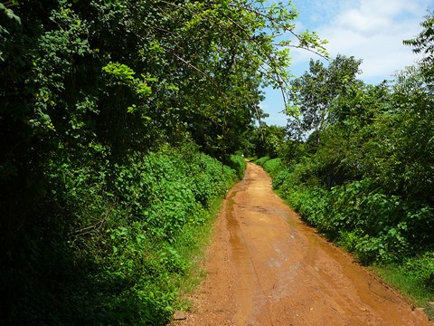

All the villagers, along with a few evangelists that had traveled in for the message, were already inside the small church worshipping and singing as one man banged on the drum.

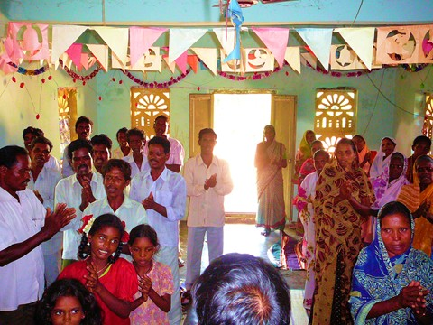
Even with the high temperature it seemed refreshing to walk in to the excitement of such pure worship. Deva and Phillip were our translators for the day and did an incredible job as we gave them small amounts of information and they relayed it in a way that the villagers could understand.

The villager’s education is so limited but we are told that once they grasp a concept they will put it into play if they have the ability. We feel led to speak on health and hygiene and understand that there has been relatively no teaching on these important subjects. So during the weekdays we will focus on those teachings and Sundays will be messages meant to build up, encourage and teach. Before leaving the U.S. we obtained information and posters from the World Health Organization and are incorporating biblical principals into the lessons as well. The Lord equipped us with a small microscope to take along, too. A large portion of the training is on the importance of knowledge to help eliminate the three greatest killers throughout the developing world, “unsafe drinking water, unclean homes and neighborhoods and improper disposal of excrement.” We also brought information on preventing AIDS, as it may soon surpass all other diseases as the greatest killer.

For those of us that live in developed countries it seems next to impossible to believe that so many people aren’t aware of these simple teachings. But as we questioned the villagers about how many of them use soap and the hands that went up were next to none, we recognized that the problems are serious.

We shared information on killing the bacteria in their drinking water and the importance of hand washing. We asked them when it is important to wash your hands and the only response they could think of was “before eating.” This was all eye-opening information and we feel confident that the Lord will use it to improve living situations and prevent unnecessary illness. As our translators questioned them they, too, felt confident that these people would incorporate many of these simple teachings into their daily lives.

Though everyone was excited about seeing a fly’s leg up close they were actually a bit frightened to see what was in the water they drink. Unfortunately the day only provided about 20 minutes of electricity. They were amazed to see the enlarged image of a fly leg and how a fly is able to grasp things with pincher type legs carrying bacteria/germs to everything they land on. Just as we put the slide up with a sample of their drinking water and they caught a glimpse of the movement in the water, the electricity went out. Perhaps that was a good thing.

After 6 hours of hygiene teachings we took a short break and went on to the second teachings of the day. This included the importance of communication in marriages. Many were very interested in this topic but as time was running out, we concluded the day there.

During the lunch break Steve and I took a stroll around the village. I had a chance to draw in the dirt with a stick and teach some of the children tic-tac-toe and hop scotch. Such beautiful children and they were very excited to learn these new games. The following are photos of these people’s village and their homes.
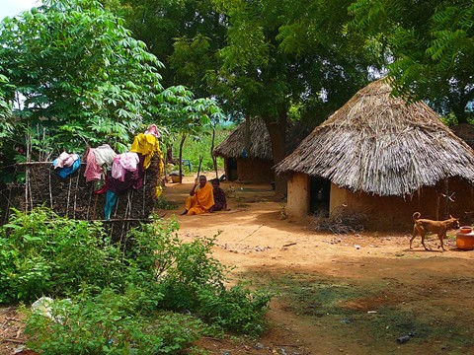

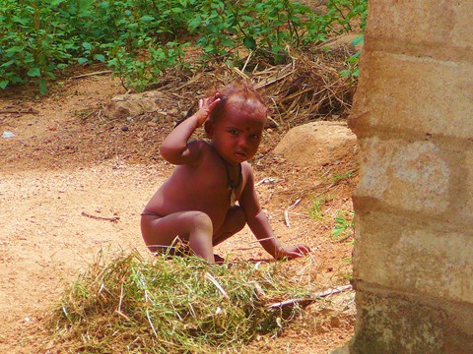

--- Why are you looking at me? ---

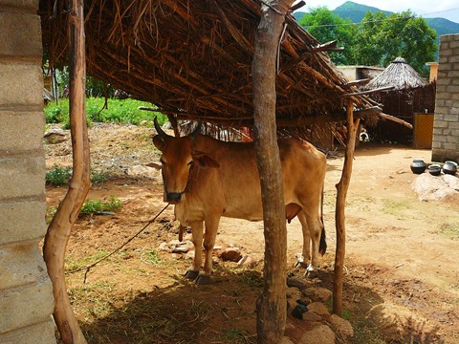

--- Cow Port ---
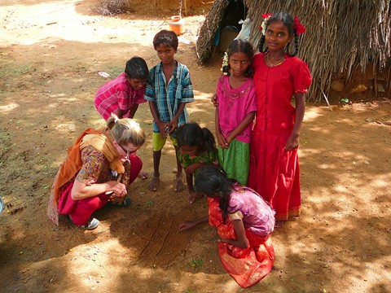
--- Teaching Tic-Tac-Toe ---

We were supposed to have an 8:00am departure on Sunday but as is so typical there was trouble finding a driver. Church services generally end by 1:00pm on Sundays and our destination was about 1 hr away with 3 church visits planned. We rolled down the road at 10:00am. The first little church was packed full and our translator, Job, told us that this church has experienced huge growth.

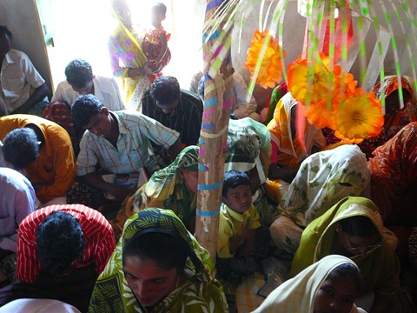

20 people have been water baptized in the last month. They are praying for church expansion as they’ve run out of room. As I gazed at these beautiful people I couldn’t help but wonder how anyone could think these tribal villagers are “untouchable.”
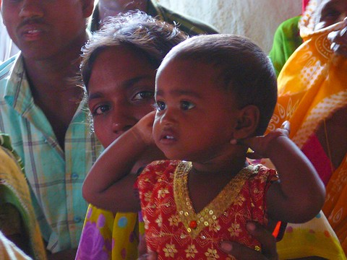

Fortunately none of us are untouchable in God’s sight and many are coming to know Him. After prayer and so many handshakes we hurried off to the second church that was located nearby and entered in to a powerful presence of the Holy Spirit.

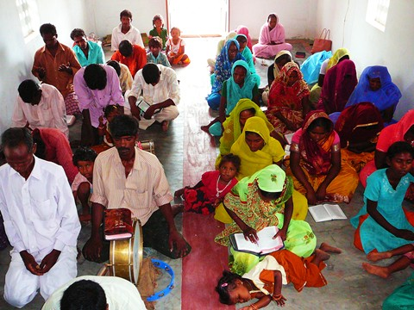

The worship was wonderful and when the “white man” began to speak everyone listened intently. These people are hungry for the Word. Since time had been cut short for the day Job went to visit a third church while Steve completed the message and we prayed individually for those with particular needs. With our 2nd translator Phillip’s help; he explained each situation and Steve prayed for the men while I prayed for the women. Praise the Lord, one previously unbelieving man said the message had really spoken to him and he accepted the Lord. 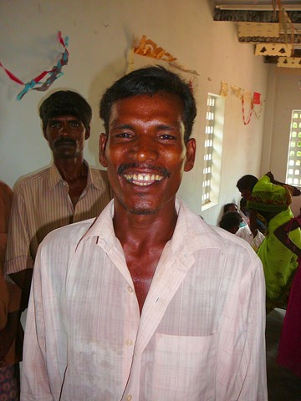
As he knelt down, Steve led him in a prayer and the men gathered around him and prayed, too. There were many different requests to pray for those who were barren, health issues, illness and demonization and one man whose arms were affected by a spitting cobra which had “licked” him while he slept. Through our translator one young girl explained that a witchdoctor in the village had put a curse on her and she had an incredible fear of snakes. As we were finishing up, Job returned from the third village with some heartbreaking news of a horrible accident that had just taken place. A man was traveling to the church with his wife and daughter and as they crossed a canal, 100 yards from the church, ocean water swept in unexpectedly and carried the woman away. The man managed to get his daughter to the edge where a woman from the church grabbed her, but when he turned around his wife was gone. We all went back to pray for them and found that the young girl named Conedema, probably 10 years old, had returned from a nearby doctor that she was taken to because she had swallowed so much ocean water. Conedema (in green) was being comforted by a young friend but was obviously in shock.
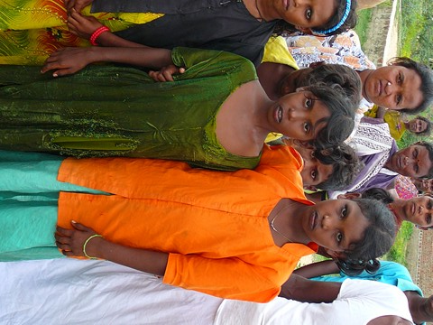

When others went searching for the woman who had been swept away they discovered her body a short distance down the canal where she had drowned. We gathered around this young girl and lifted her and her father to the Lord and as I began to cry through my prayers I could hear the sobs of her spiritual family and friends.

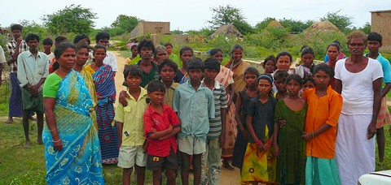

Thank you Lord that this woman knew you. So often we think that we are invincible but this incident reminds us of the fragility of life.

During the week we experienced a birthday party for a boy who turned one year old. This boy’s name is Nehemiah Moses. His father is the pastor of the village. The party consisted of praying, singing, sharing the word and then sharing a birthday cake and popping balloons.

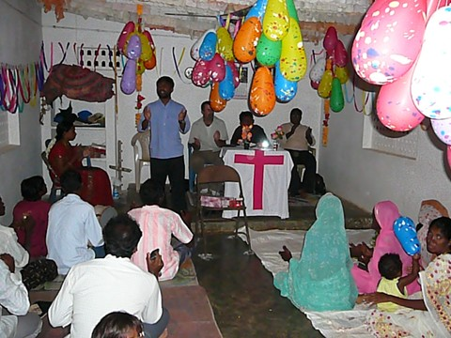
Quite different from our birthday parties in the U.S. This was all done in complete darkness since the celebration was during the evening hours and there wasn’t any electricity. The evening ended as we shared a dinner together prepared by the pastor’s wife.

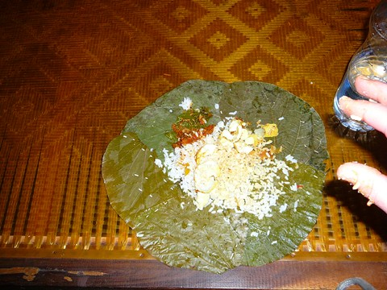

Two nights later we enjoyed another birthday celebration with the same type of program as the last one, but for a little girl named Madhuri. 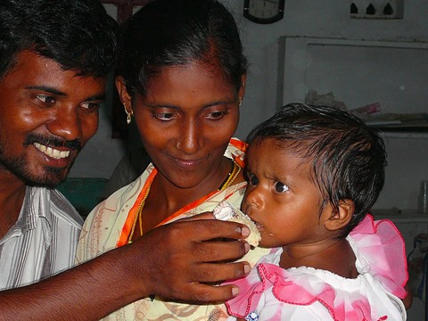
On this particular evening we were able to connect with our Pastor Lou in the US for a short time so he could enjoy the music and singing, too. It was really enjoyable to know that they were experiencing it right along with us.

On Wednesday the village that we visited was 3 hours away from the Alma Orphanage. We actually got an early start (8:00am.) We’re talkin’ boondocks; this place was in the middle of nowhere!

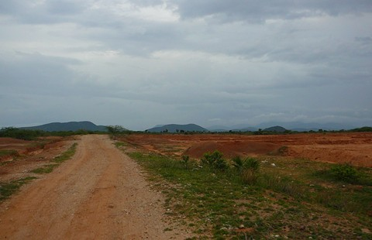

The day began with singing and music, followed by a message and then the entire afternoon was spent on the health/hygiene program and a hair cutting ceremony for a small boy.
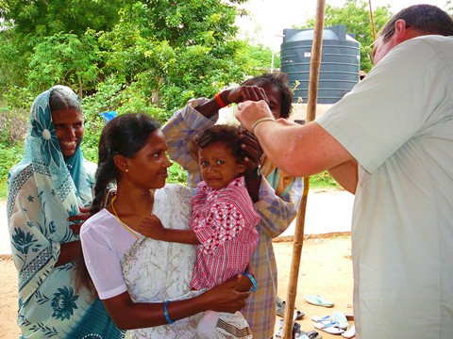
These ceremonies are done when they dedicate their children to God. Prior to leaving we were asked to go and pray for a woman that has been bed ridden for three years.

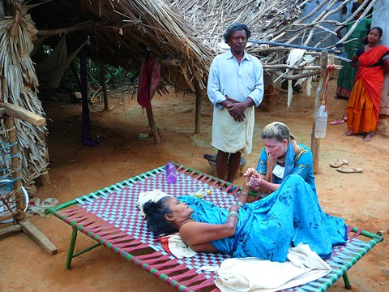

In 2007 this woman was bathing near her house, pouring water over her head, when she felt something poke her in the side 2 times. She looked to see what it was and was stunned when she saw a King Cobra. She thought she had been bitten and ran away. A few days later she stepped on a gunnysack that was in front of her door and a King Cobra was under the sack. She jumped to get away from it and took a spill, injuring her back. Shortly after that a cat drug some kind of small animal into her house, possibly a squirrel or a rat. When the cat let it go it ran up her skirt and as she tried to get away, she took another fall. After the second fall she began having so much pain in her back that she couldn’t walk. She has been to many doctors since that time, all saying they can’t help her. She is now completely unable to walk. Her family feeds her and transfers her outside to lie on a cot during the day. Her body is very frail and her eyes convey her distress. For many reading this it will seem like an outlandish tale, but this is everyday life for so many people.

We rolled in to the orphanage at 10:30pm, stuffed some trail mix in to our mouths, showered and drifted off listening to our headsets.

The following incident was so comical, and gives a great example of cultural differences, that I had to share it. Our friend accompanied us to town to pick up a few groceries on Thursday. Steve had heard about a possible pizza place and asked Prashad if he knew where it was. Prashad knew of the place and since it was nearby we decided to give it a try. The name of this place is “Amigo’s Pizza.” The name alone says quite a bit. As Prashad looked over the menu we all laughed because he wasn’t even sure what the choices were. We decided upon a cheese pizza and a vegetable pizza. Prashad placed our order and a few minutes later a man returned to let us know they only had one pizza shell available. It looked quite a bit like an 8” round pita bread. We started to laugh and said, “okay, we’ll just take one pizza then, could we do half cheese and half veggies?” Americans are so difficult! As they cooked our pizza I asked Prashad if he could show me some of the items on the menu that were actually available in the display case of already made food. Prashad would point to an item on the menu and ask the man behind the counter which one it was. 5 times out of six the man replied, “Oh, we don’t have that one.” It was so funny and we all had a good laugh. They prepared our pizza and delivered it in two separate “to go” boxes because they didn’t want the two different types to touch. They are so considerate and really wanted to accommodate us. All I can say is that pizza in India is an amusing experience, but you may not be able to experience it yourself. It seems that we got the last one!

Friday was another long day. We traveled to a village that we had visited last year for more hygiene training, a biblical message and 3 baptisms. These people are so loving, kind and grateful for the teachings. It was such a wonderful day and we were so excited again when our translators indicated that they really believe that these villagers will implement many of the things they have learned. Steve took a sample of water from a small puddle outside of the church that people were stepping in and kids were running through. When the local evangelist and Steve watched as a microscopic worm slithered through the sample, it made a great impact on them all of the unseen things that can be causing so many illnesses.

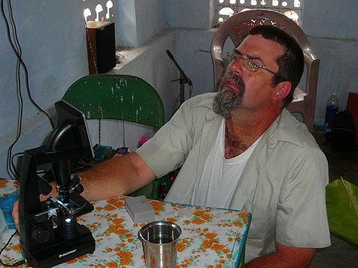
The baptisms took place about 15 km. from the village. 8 of us drove off in the Alma vehicle and the rest followed in a crowded tuk-tuk.

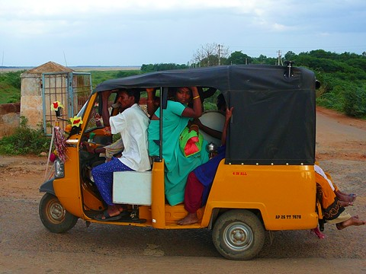

As they pulled up in the small rented auto I had to laugh at the sight. They were all singing at the top of their lungs while the faithful drummer banged out a time. Everyone marched down to the water singing and celebrating for the 3 that had made decisions to follow Jesus.
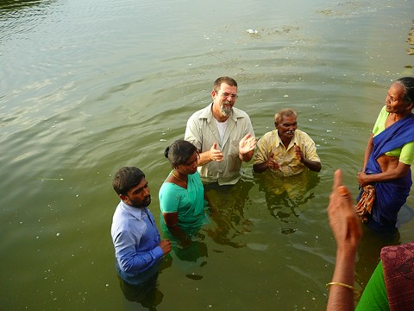

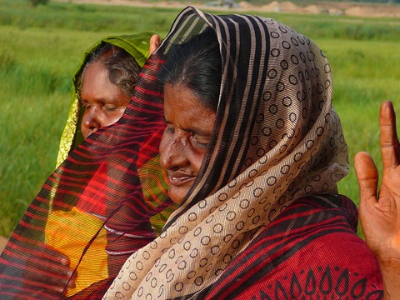

As we continue to experience the Lord’s hand at work here in India we can’t believe how fortunate we are to be a very small part of what He’s doing. We wish everyone had the opportunity to see these things first hand. We are so blessed and continually grateful that we can share how God is moving and pray that our simple efforts will help you to feel a part of it, too.

You can see that there is much to pray about. Won’t you join us as we stand in the gap for the people of India? And pray for us to be Spirit led in all we do.

Steve and Denise - “Just Foot Soldiers”

