The Monica Project
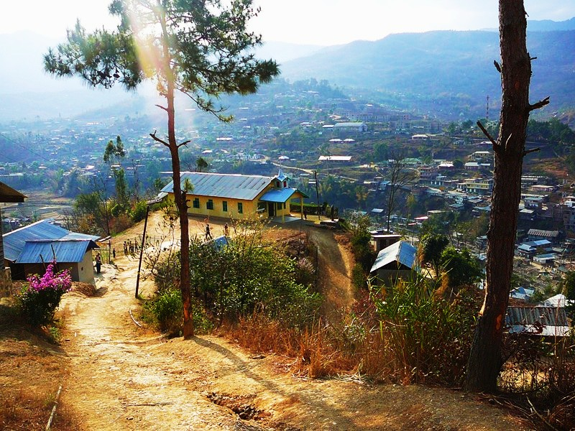
We would like to introduce you to a small remote village located in Northeastern India. The village of Angkailongdi was established in 1966 by Mercy’s Grandfather. Her Grandfather had come from a mountain jungle village located approximately 8 hours walking distance away. He was granted land at that time but the tribe didn’t actually move to the village until the 1980’s. The government eventually provided the town of Senapati and the surrounding villages with access to electricity in 2007. They are only given 1-2 hours of power daily since it is provided at no cost simply because most people can’t afford it. Unemployment in this area exceeds 90% making each day a struggle just to have food and shelter for the family. Water is only accessible from a community hand pump or from a holding tank that sits atop the village. This requires many trips a day up and down the mountainside, filling water vessels and then hauling them back home just to have water for cooking and bathing. Medical facilities are essentially non existent and though a public school was established a few years ago most villagers cannot afford the school fees.

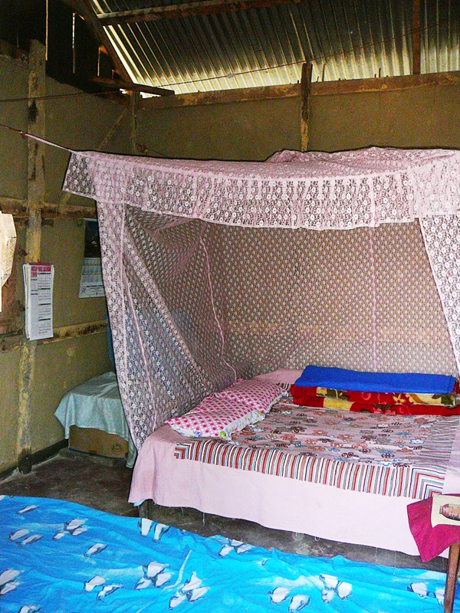
Upon our arrival, we were introduced to our friend Sunny’s family and shown to our new home during our stay. His wife Mercy and her mother Daila, along with many village people, had been laboring for weeks in preparation of our arrival. We were incredibly touched when we saw our room and all the trouble the village had gone through to make us comfortable. Everyone had lent their sheets to cover the mud floor, blankets, a mosquitos net, and whatever cooking suppplies they had to accommodate the first foreigners ever to visit their village. They had even built a raised bed for us. Just outside the house they had constructed a bathroom and small closet size area for bathing.

After we had settled in we began visiting some of the local families. Our hearts ached as they shared their stories of troubles and family losses. One woman named Rose (picture bottom left) relayed a common story of unknowingly selling her 11 year old daughter to those who prey on small children for sex trafficking by lying to their parents and telling them that they will be given good jobs and can send money home to their families. Fortunately Rose found out the truth a week later and through a miracle some men from the village were able to rescue her daughter. Rose also told us about her 4 yr old son (bottom center and right) who recently died after falling ill.

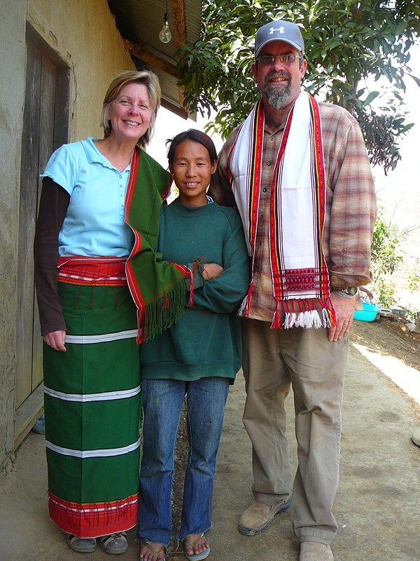
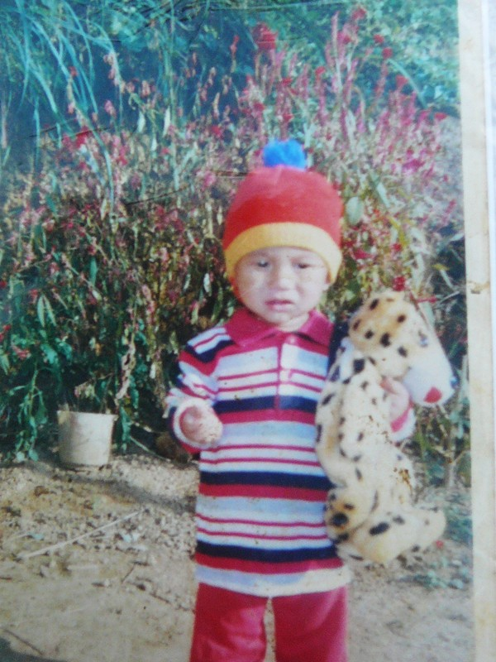
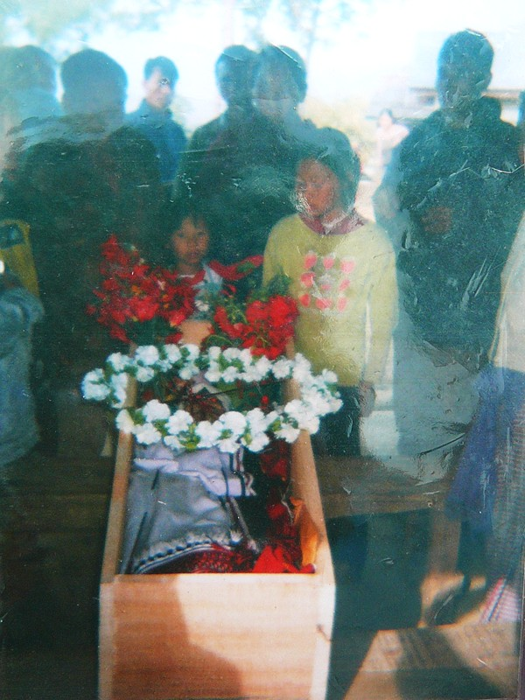
Alcoholism, drug abuse, illness, death, etc. were typical of the trials they related but considered a standard way of life for these people. Most people showed us small photo albums of their loved ones funerals. It didn’t take long to realize that there is simply no knowledge or practice of basic hygiene techniques. If there were it could make such an incredible and positive impact in the area of health for these peoples lives. When you cannot afford to buy food for your family you certainly cannot afford to buy soap and without the availability of clean hot water, killing germs isn’t even a thought in their minds. As an example many mothers have their children blow their nose into their hand and then they will go on to prepare a meal without washing their hands. It isn’t a surprise that viruses are spread as rapidly as they are.
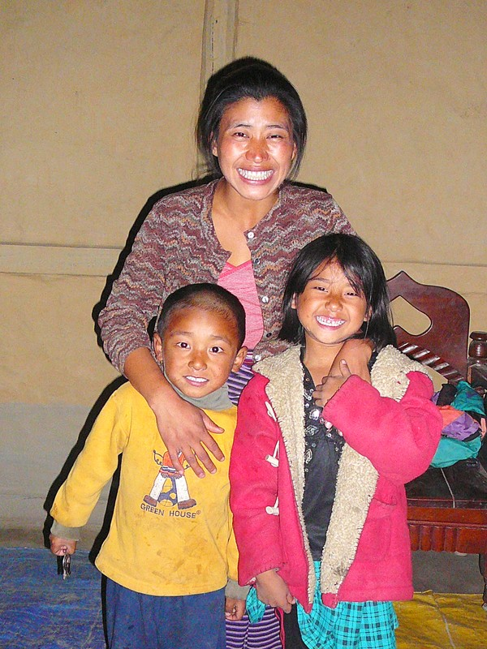
We met a young widow named Monica who has three young children. Monica’s husband, a pastor, had died a couple of years ago apparently from cancer but once again without medical facilities it’s merely a guess as to why. Monica now lives with her brother, his second wife and their two children. Monica’s brother lost his first wife and one of their children a few years ago, again for unknown reasons. Monica is a lovely woman with a beautiful smile and though the experiences of the last few years have left her weary, she is optomistic and eager to learn.
One morning the Lord placed it on our hearts to approach Monica with a proposition to travel to Zimbabwe Africa for training by a doctor that we had met there a few years earlier named Judy. With this training Monica could return to her village and open a medical clinic for Angkailongdi and the surrounding areas. Due to the lack of any form of communication we had to wait to email Judy until we returned to “civilization.” We spoke with Sunny and the tribal leaders about our thoughts and they were all on board. As we relayed the idea to Monica and waited for her response, she sat on the floor of the small mud hut where we spoke and wept at the prospect of being able to help her village and her people.

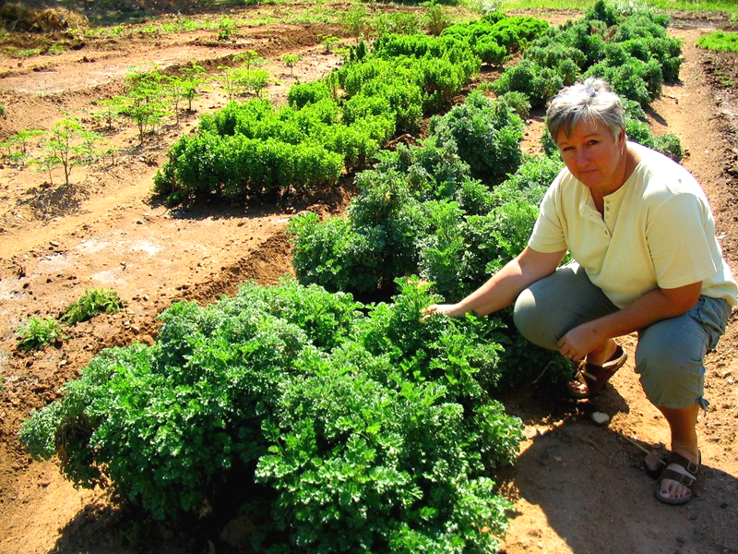
Though Monica has limited English skills, she is now studying spoken and written English daily. The king of the village will grant a piece of land for the medical clinic and an area for growing all the herbs and plants necessary to make the much needed medicines.
We emailed our friend Judy in Zimbabwe and she responded by telling us she thinks this is an excellent idea. She is excited to move forward whenever possible.
Through your donations we hope to acquire the funds necessary to bring Monica to Africa in the early part of 2010. She will remain there for a minimum of three months for training. During that time Monica is willing to put her children in a local hostel for their care. Monica has never travelled out of her own village so we will fly to Manipur India and travel with her to Doma, Africa where the current medical clinic and Judy Ervine are located. Plans are currently being discussed with a company in China to donate and ship a small building to Manipur to be used for the clinic. During our visit to Doma, Africa we are investigating the opportunity to document the training program that Monica will learn so it may be used for future training of others with the same urgent needs.

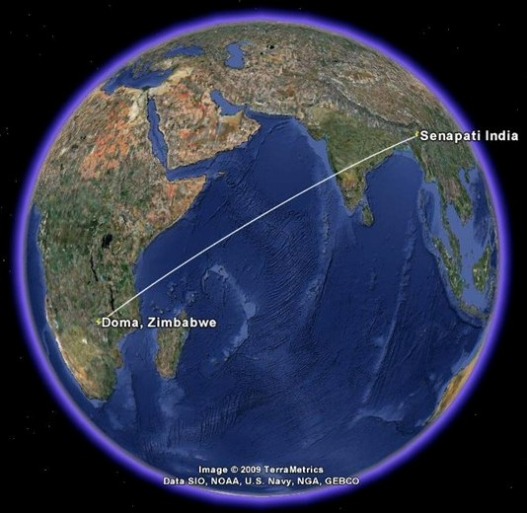
Thank you for your interest in our Ministry and this project. If you would like to receive our newsletter, be included on our prayer chain, help out financially or are interested in going on a short-term mission, you may contact us at:
Steve and Denise Bol, 10214 Mallard Way, Auburn, CA 95602 (530)269-0181 opabol@yahoo.com

To make a donation, please make checks payable to “Passion 4 People Int’l” and depending upon where you would like to designate the funds state either “Monica Project” or “Steve and Denise’s Ministry” in the memo area.
Mail to: Steve & Denise’s Ministry, 2374 Bean Road, Auburn, CA 95603

